4-5th Generations of Computers

Introduction

First Generation, 1946-1959

They consisted of large devices like vacuum tubes, first machine language – 1GL(First Generation Language), punch cards, paper tape and magnetic tape were used to enter data into computers.

Computers: ENIAC, EDVAC, UNIVAC, IBM-701, and IBM-650

Second Generation 1959-1965

People started using transistors

Languages: COBOL, FORTRAN

Computers: IBM 1620, IBM 7094, CDC 1604, CDC 3600, UNIVAC 1108.

Third Generation, 1965-1971

The difference of this gemeneration is that Integrated Circuites were used. IC is a small device which contain a lot of small devices such as transistors, resistances and other.

Languages: COBOL, FORTRAN-II up to FORTRAN-IV, PASCAL, ALGOL-68, BASIC

Computers: IBM-360 series, Honeywell-6000 series, PDP (Personal Data Processor),  and IBM-370/168.

4th Generation

When in the first generation vacuum tubes were used, in second – transistors, in third – integrated circuits, the fourth generation was the time when microprocessors appeared. It was between 1971 – 1980. So, microprocessors also known as VLSI chips (Very Large Scale Integrated). Intel was the first company to develop microprocessor. VLSI circuits had almost about 5000 transistors on a very small silicon chip. Due to the technology used to build fourth-generation computers, they came with various features such as more versatile, large primary storage capacity, excellent in speed and reliability, portable, very compact and small, etc.

In this generation, computers have become more popular as they are sold at the lowest price. The first “personal computer” or PC belonged to this 4th generation and was developed by IBM.

Examples of computers are STAR 1000, CRAY-X-MP(Super Computer), DEC 10, PDP 11, CRAY-1.

The computer languages like languages like C, C+, C++, DBASE etc. were the input for these computers.

Advantages of the 4th generation:

* These computers used a VLSI (Very Large-Scale Integration) circuit that integrates millions of transistors.
* The fourth-generation computers are cheaper in price as compared to the previous three generations of computers.
* They emerged single-board computer and the single-chip processor.
* This generation of computers improved in terms of speed, accuracy and reliability.
* Due to the high component density, they were small in size comparing to previous generation's computers.
* In the fourth generation, multiple high-level languages like BASIC, PASCAL, COBOL, FORTRAN, and C language were developed.
* Additionally, the personal computer (PC) revolution also developed because of the features of fourth generation computers.
* The use of data communication was widespread because of these computers.
* The development of the networking between the systems began in the fourth-generation computers.

5th Generation

The Generation begin somewhere in 1981 and is present generation. In this generation, the VLSI technology has advanced and become ULSI technology, stands for Ultra Large-Scale Integration. That means ten million electronic components were used in the production of microprocessor chips.

The computer made in the fifth generation was created with the help of logic programming and massively parallel computing. This generation of computers was based upon parallel processing hardware and [AI (Artificial Intelligence)](https://www.javatpoint.com/artificial-intelligence-tutorial) software. Artificial intelligence has the ability to illustrates the means and method of making computers think the same as human beings. In this generation, all kinds of high-level languages such as [C](https://www.javatpoint.com/c-programming-language-tutorial) and [C++](https://www.javatpoint.com/cpp-tutorial), [.Net](https://www.javatpoint.com/net-framework), [Java](https://www.javatpoint.com/java-tutorial) and more are used.

The systems that include AI are being used in numerous real-life applications and provide various benefits. In the conditions that need knowledge and skills of a type, these systems can perform well in these types of situations that a human can receive with the help of formal training. However, they are unable to fit in the situation where the need for tacit knowledge where a human can receive the tacit knowledge by communicating in natural language and concerned with shape and speech recognition.

Advantages of the 5th generation:

* The computers of fifth-generation use AI (artificial intelligence) technology that includes: Development of expert systems, Game Playing, Robotics, Natural language understanding, and Neural Networks.
* The AI technology made these computers to understand human language as well as recognize graphs and pictures.
* The development of fifth-generation computers is intended to solve highly complex problems, including working with natural language.
* Hopefully, they will be able to use more than one CPU and less expensive compared to the recent generation.
* It is very easy to take these computers from one place to another and to repair them.
* The computers made in the fifth generation can be handle easily.

Vacuum Tubes

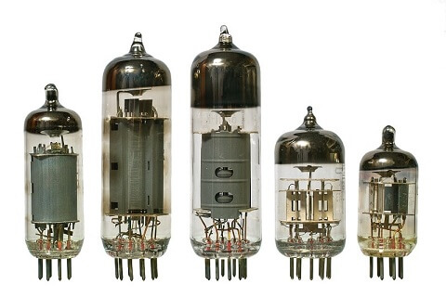 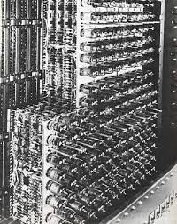

Transistors

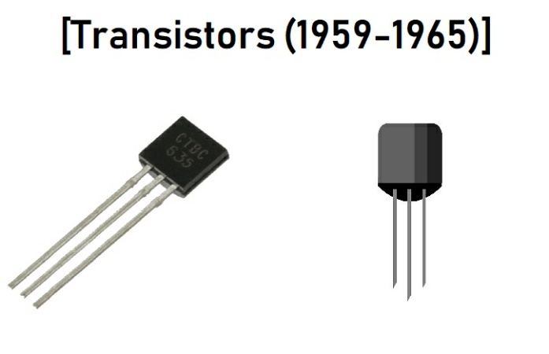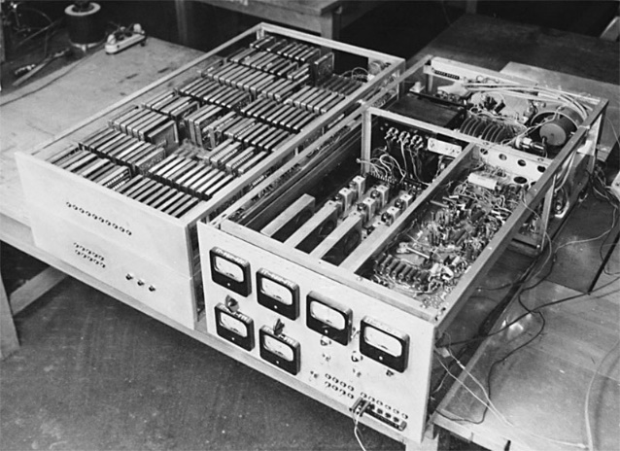

Integrated Circuits

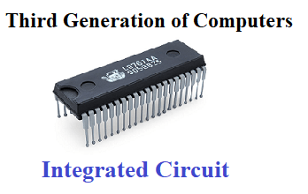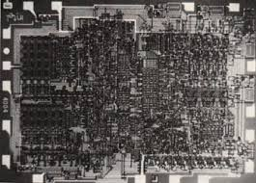

VLSI Circuits (Microprocessors)

